ILLUSTRATIONS: FREEPIK

Move & Groove

FITNESS TRACKER

|  |  |  |
| --- | --- | --- |
| DATE | ACTIVITY | MINUTES |
|  |  |  |
|  |  |  |
|  |  |  |
|  |  |  |
|  |  |  |
|  |  |  |
|  |  |  |
|  |  |  |
|  |  |  |

Move & Groove

WHAT ARE SOME OF YOUR FAVORITE

ACTIVITES TO GET ACTIVE?

ACTIVITY

1. _______________________________
2. _______________________________
3. _______________________________
4. _______________________________

ILLUSTRATIONS: FREEPIK

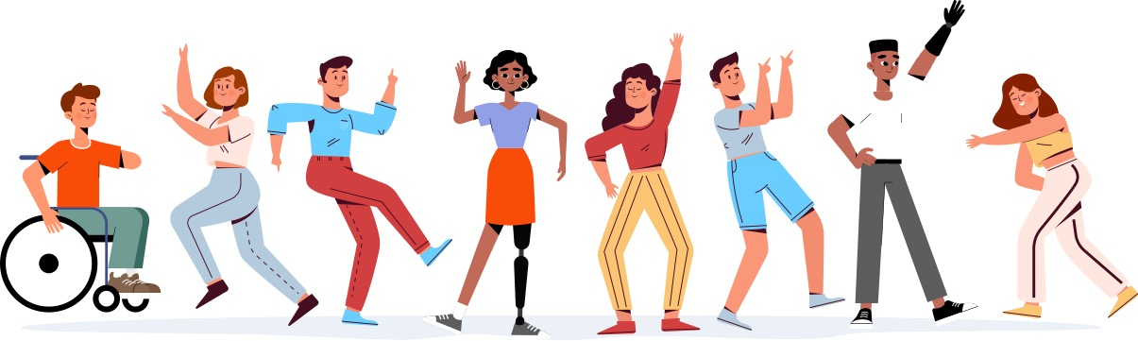

Move & Groove

FITNESS TRACKER

|  |  |  |
| --- | --- | --- |
| DATE | ACTIVITY | MINUTES |
|  |  |  |
|  |  |  |
|  |  |  |
|  |  |  |
|  |  |  |
|  |  |  |
|  |  |  |
|  |  |  |
|  |  |  |

ILLUSTRATIONS: FREEPIK



Move & Groove

WHAT ARE SOME OF YOUR FAVORITE ACTIVITIES TO GET ACTIVE?

ACTIVITY

1. _______________________________
2. _______________________________
3. _______________________________
4. _______________________________

ILLUSTRATIONS: FREEPIK